Project assessment

Criteria

Unit code and name
CI_LayoutStyleMarkup
ICTWEB431 – Create and style simple markup language documents
ICTWEB432 – Design website layouts
ICTWEB433 – Confirm accessibility of websites
ICTWEB452 – Create a markup language document

Qualification/Course code and name
ICT40120 | Certificate IV in Information Technology

Student details

Student number
880631950

Student name
Dylan O'Reilly Salinger

Assessment declaration
Note: If you are an online student, you will be required to complete this declaration on the TAFE NSW online learning platform when you upload your assessment.
This assessment is my original work and has not been:
- plagiarised or copied from any source without providing due acknowledgement.
- written for me by any other person except where such collaboration has been authorised by the Teacher/Assessor concerned.

Student signature and date

Version: 20250519
Date created: 8 April 2022
Date modified: 21/10/2025

For queries, please contact:
Technology and Business Services SkillsPoint
© 2022 TAFE NSW
RTO Provider Number 90003 | CRICOS Provider Code: 00591E
This assessment can be found in the: Learning Bank
The contents in this document is copyright © TAFE NSW 2022 and should not be reproduced without the permission of TAFE NSW. Information contained in this document is correct at the time of printing: 21 October 2025. For current information please refer to our website or your Teacher/Assessor as appropriate.

Assessment instructions
Table 1 Assessment instructions
Assessment details | Instructions
Assessment overview | The aim of this assessment is to assess your knowledge required to scope web page requirements and to create and implement designs according to client requirements. It also assesses your skills and knowledge required to design and create basic markup language documents and cascading style sheets (CSS) in order to define the structure and style of a website, while adhering to international and Australian industry standards and practices.
Assessment event number | 2 of 2
Instructions for this assessment | This is a project-based assessment that assesses your knowledge and performance of the unit.  This assessment is in 5 parts:  Part 1: Understanding the website requirements.  Part 2: Planning the website.  Part 3: Creating the website.  Part 4: Test and validate the website.  Part 5: Obtaining feedback and sign-off.  And is supported by:  - Assessment checklist  - Assessment feedback  - Appendix 1: Enterprises Accessibility Policy for Website Development  - Appendix 2: Website test results documentation template  Note: This assessment may contain links to external resources. If a link does not work, copy and paste the URL directly into your browser.
Submission instructions | On completion of this assessment, you are required to submit it to your Teacher/Assessor for marking. Where possible, submission and upload of all required assessment files should be via the TAFE NSW online learning platform.  It is important that you keep a copy of all electronic and hardcopy assessments submitted to TAFE and complete the assessment declaration when submitting the assessment.
What do I need to do to achieve a satisfactory result? | To achieve a satisfactory result for this assessment you must answer all the questions correctly.  If a resit is required to achieve a satisfactory result it will be conducted at an agreed time after a suitable revision period.
What do I need to provide? | - TAFE NSW student account username and password. If you do not know your username and password, contact your campus or service centre on 131601.  - Computer or other device with word processing software and internet access  - Writing materials, if required
What the Teacher/Assessor will provide | Access to this assessment and learning resources, including the student workbook and any supporting documents or links.
Due date  Time allowed  Location | Refer to UAG for details  Nine hours (indicative only)  Assessment is to be completed out of class.
Assessment feedback, review or appeals | In accordance with the TAFE NSW policy Manage Assessment Appeals, all students have the right to appeal an assessment decision in relation to how the assessment was conducted and the outcome of the assessment. Appeals must be lodged within 14 working days of the formal notification of the result of the assessment.  If you would like to request a review of your results or if you have any concerns about your results, contact your Teacher/Assessor or Head Teacher. If they are unavailable, contact the Student Administration Officer.  Contact your Head Teacher/Assessor for the assessment appeals procedures at your college/campus.

Specific task instructions
The instructions and the criteria in the tasks and activities will be used by the Teacher/Assessor to determine if you have satisfactorily completed this assessment event. Use these instructions as a guide to ensure that you demonstrate the required knowledge and skills.
Refer to these instructions given carefully before proceeding with the Part 1 (Designing the website) assessment:
- Go through the instructions carefully before attempting the project assessment.
- Ask your instructor for the sample resources provided by TipToe Soles (the fictitious Shoe company used for this project)
- Use the templates provided to complete and document completion of each task.
- Sample resources have been provided and should be used for reference purposes only. They are meant to provide a starting point for your designs.
- The information in the scenarios and the resources provided are for inspiration. You may add on elements to enhance your work. (Be mindful of the time allotted)
- Talk to your instructor for any clarifications.

Scenario
You are working as a Lead Website Designer for Gelos Enterprises. Gelos is an IT organisation with a proven track record in web development and cybersecurity. As a policy, the organisation not only serves multi-national companies, but a separate division also caters to the requirements of small-sized organisations.
Gelos has been approached by TipToe Soles, a shoe manufacturing company based in Sydney, Australia. The company has been manufacturing and providing their products as a white label to various other brands. The management of the shoe company now wishes to launch its own brand in the market at affordable costs.
TipToe Soles has contracted Gelos Enterprises to develop and build a responsive e-commerce website for its first range of products to be launched shortly. The objective of this website is to enable customers to view and purchase products online. As the Lead Website Designer for Gelos Enterprises, you are responsible for this project.
TipToe Soles management has a vision for the brand to be the go-to affordable footwear brand in Australia and around the world.
The first range of products that will be launched are comfort or daily wear shoes targeting customers of age 30 and above. The website should have a minimalistic design to avoid any unnecessary distractions.
TipToe Soles management has provided a brief description of how they visualise the structure of their website. The website should have a main menu toward the left side of the screen with a banner across the home page wherein the latest arrivals shall be displayed. The main menu should contain about us, products, services, login, wishlist, contact option tabs, as well as a search bar and feedback form. The footer of the home page should include hyperlinks to return policies, exchange policies, delivery policies, etc. And of course, each page should hold the brand logo at the top left corner. The colours used should be monochromatic but must not be too heavy on the eyes.
The website should be compatible with most platforms and be reasonably backwards compatible. This means that the website should be compatible with computers running Windows (Windows 7 and above) and macOS (macOS 10.12 and above) operating systems, as well as mobile devices running iOS and Android. The website should also support all popular web browsers such as Chrome, Firefox, Internet Explorer, Edge, Safari to name a few. The company also uses Microsoft IIS server as it is a flexible, secure and manageable web server for hosting anything on the web.
For the website’s product section, similar types of products should be grouped together and displayed in a list format and a payment gateway can be eventually integrated as well.
The brand logo and the website content shall be provided by TipToe Soles. Any images included in the website should have an aspect ratio of 4:3.
Since the company is confident about the quality of their products, they’re sure that the website would experience high traffic and don’t want to face any compatibility or performance issues as any downtime would result in loss of business. Further, it should comply with existing state and federal laws. Website accessibility is a key concern for TipToe Soles management as well as Gelos Enterprises. As such, you should ensure that any website development you undertake is in compliance with WCAG 2.0 Standards.

Part 1: Understanding the website requirements
The first part of this project is to understand the client requirements which provide the underlying foundation of the website being developed. In this section, you will be tested on your analysis of client’s requirements.

Task 1 – User analysis
Review the previous scenario and determine the user profile and requirements for the TipTop Soles e-commerce website. Document your findings in the following table:
Table 2 User Analysis
No | User profile/requirements | Description
1 | Target audience | People over 30
2 | Location of target audience | Predominantly Australia
3 | Mode of payment to be used by the audience | Pay Pal, Afterpay, credit/debit card
4 | Design preferred | Monochrome, main menu to the left, minimalistic
5 | Operating system(s) 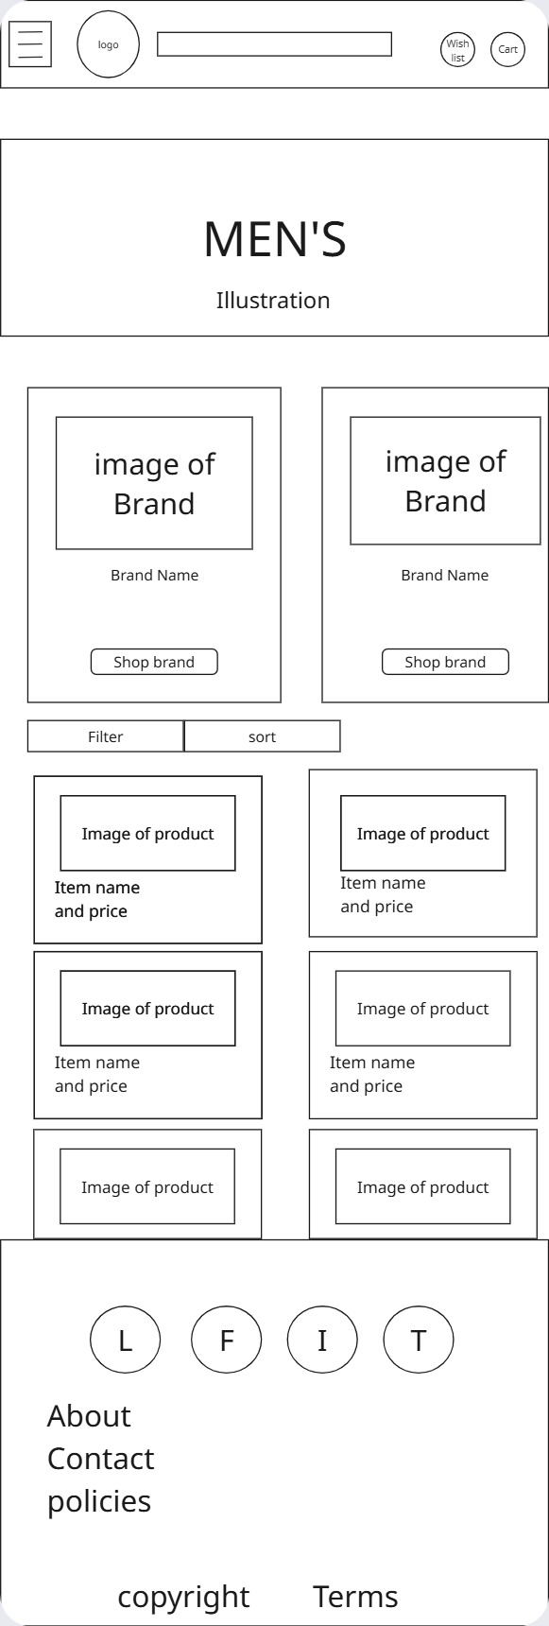 | Windows 7 & above, MacOS 10.12 & above
6 | Hardware preferred | Computers, Phones, tablets
7 | Web browsers preferred | Firefox, chrome, edge, Safari
8 | Web server preferred | Microsoft IIS
9 | Any other information

Task 2 – Establish TipToe Soles website requirements
Now that we have identified the requirements of the website user, it is now time to elaborate on the website design. This includes identifying and defining the aspirations of the client with respect to the product, as well as the functional requirements of the product.
Review the previous scenario and complete the following table briefly summarizing the client’s vision for the website and their 17 functional requirements.
Student Note: you do not need to include any information you have provided in Task 1.
Table 3 Website Requirements
No |  | Client Requirements | Description
1 |  | Vision of management
Website Functional Requirements
2 | Menu | The client wants the site menu to be to the left side
3 | Navigation bar | The navigation bar helps guide users to the part of the website that they want to visit
4 | Product tab | Contains links to the lproduct pages
5 | Services tab | Size guide, returns, aftercare
6 | Login icon | Takes user who already has an account to login page
7 | Wish list icon | Shows items in Wishlist
8 | Search bar | Search different parts of the website
9 | About us tab | Takes user to about us page
10 | Brand logo | Shows the logo of the brand and
11 | Payment gateway | Takes payments for orders
11 | Website content | The items that are required to make the website functional
12 | Images | Shows images of products so the customer understands the shoe they are buying
13 | Colour schemes | The colours that will be used on the website
14 | Forms | Fill out forms to
15 | Footer | Shows more links to go to different pages
16 | Banner | Showing different parts of the website to go to
17 | Compatibility | Should be compatible with win 10 and above and macOS 10.12
18

Task 3 – Develop the testing approach
Determine the most appropriate mark-up language to build the front-end of the website and document your response:
HTML5
Develop the testing approach to be used to test the finalised website from the following testing categories:
- Functionality
- Usability
- Interface
- Compatibility
- Security
- Performance
- Database
You should select at least 3 testing categories and:
- use the following template to define 2 test cases for each testing category
- create a testing checklist containing at least 8 items.
- Test Category:
Table 4 Test case #1
Test case #1
Description | Compatibility with safari on IOS
Test steps | Open the website on the IOS device
Test data | Not applicable
Expected result | The website loads and functions properly
Actual result | Tbc
Pass/fail | tbc
Table 5 Test case #2
Test case #2
Description | Compatibility with brave on Android
Test steps | Open the brave browser on android
Test data | Not applicable
Expected result | The website will load the mobile version of the website
Actual result | N/A
Pass/fail | N/A

Test case #3
Description | Search function test
Test steps | Search for the name of a product
Test data | Shoes, comfy,
Expected result | Will see relevant products
Actual result | N/A
Pass/fail | N/A
Test case #4
Description | Test dropdown menu
Test steps | Open the brave browser on android and load into
Test data
Expected result
Actual result
Pass/fail
Test case #5
Description |  | performance
Test steps |  | Load the website with a browser developer tool and record the render time
Test data
Expected result
Actual result
Pass/fail
Test case #6
Description |  | Compatibility with brave on Android
Test steps |  | Open the brave browser on android
Test data
Expected result
Actual result
Pass/fail
b) Testing Checklist:
- A
- D
- s
- s
- s
- s
- s

Part 2: Planning the website
Once we have documented the requirements of the user, it is now time to document the product requirements. The client has briefly described in the scenario how they wish their website to look like and, in this part, you will further explore the client’s requirements and plan the website.

Task 1 – Develop a structure of the website
Determine and organise the content required for the website:
- Analyse the website requirements to:
  - determine any additional content required by the client
  - determine any additional content required by the users.
- Group and prioritise the content into categories (pages and subpages) so the content will be logical and accessible to users.
- Using the information from the previous step, create a digital sitemap diagram of the overall website hierarchy based on your grouped content.
- Create digital wireframes as templates for the page layout, including one for the home page and one or more for internal pages (for both a landscape desktop view and portrait mobile view).
Use may use MS Word or MS PowerPoint to create your diagrams/designs.
Submit the digital wireframe screenshot(s) as evidence.
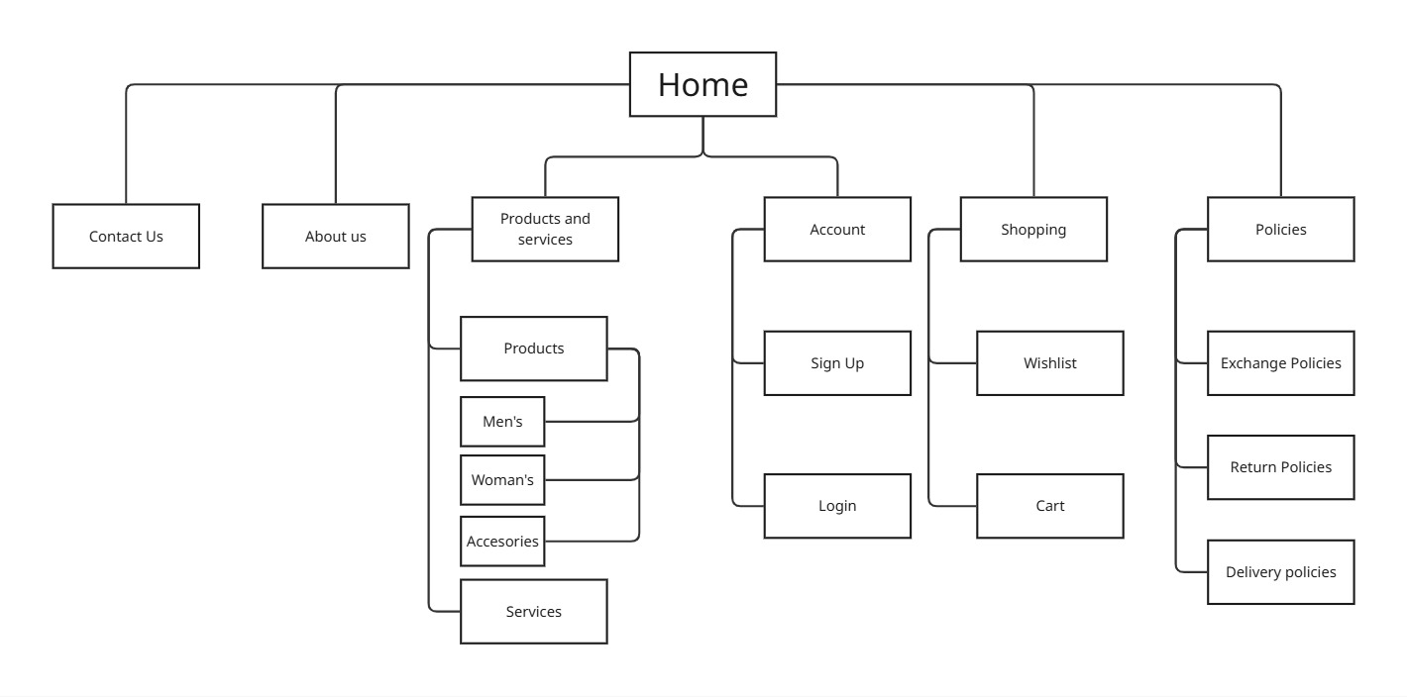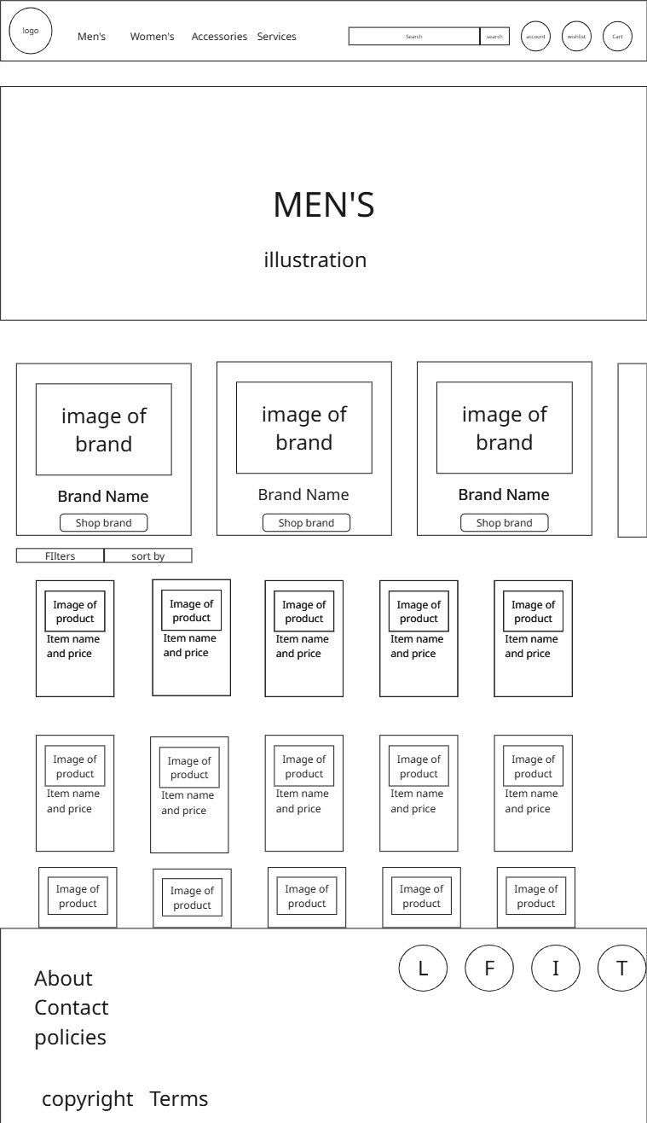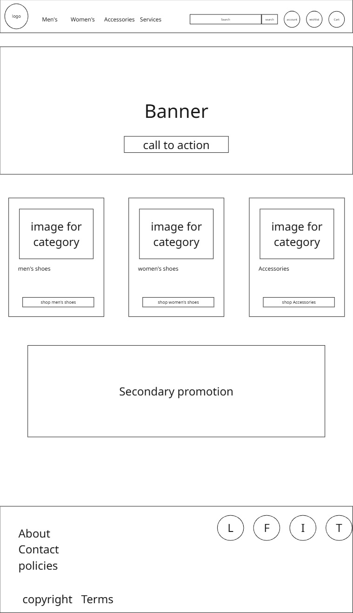
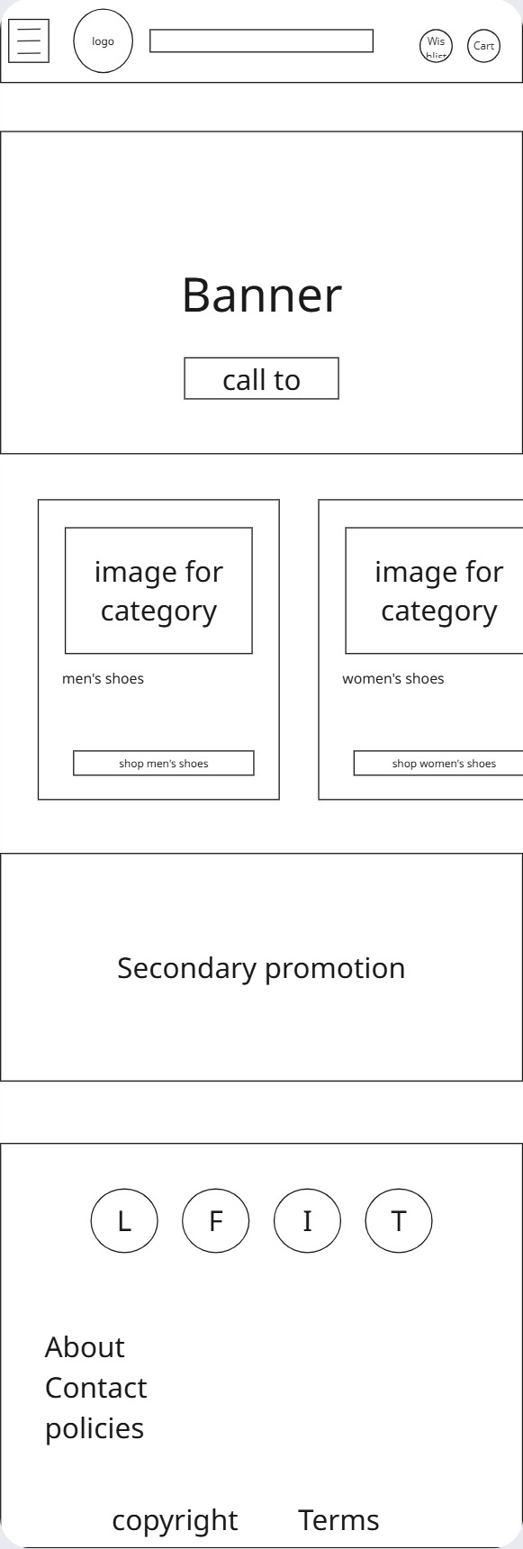

Task 2 – Accessibility planning
Accessibility refers to the ability of individuals with special needs to perceive, comprehend, navigate, and engage with websites and tools, as well as their ability to contribute equitably and without barriers.
Review the Enterprises Accessibility Policy for Website Development (Appendix 1) and WCAG 2.0 Accessibility Standards and prepare an accessibility checklist to complete as part of the development of the website.
- Images
- All non-decorative images such as brand logos, product images and the company logo must have alt text attached
- Must verify alt text by hovering cursor over images
- All alt text must be as descriptive as possible for vision impaired people
- Make sure the text remains legible even if image is scaled larger
- Audio and Video recordings
- all audio and video content on the site must have subtitles and/or transcription available
- make sure that if there is auto playing audio make sure it can be easily muted or paused
- Colours
- Make sure that the colour of the text contrasts the background for the best readability
- Make sure to not use colours to convey information
- Make sure to use the free colour contrast analyser to check the contrast
- Text
- Make sure that all text can be scaled larger without hindering the website functionality
- Links
- Make sure that links clearly convey or display where they are going
- if going to a document or PDF make sure to include the kind of file and the size of the file
- Site navigation and structure
- make sure that the website can be viewed without the use of a mouse using methods like tab and enter buttons
- make sure that the website is laid out in a way the is reasonable and intuitive
- Forms
- Make sure that all fields that require user input are labelled in a way that the user understands the data that needs to be entered

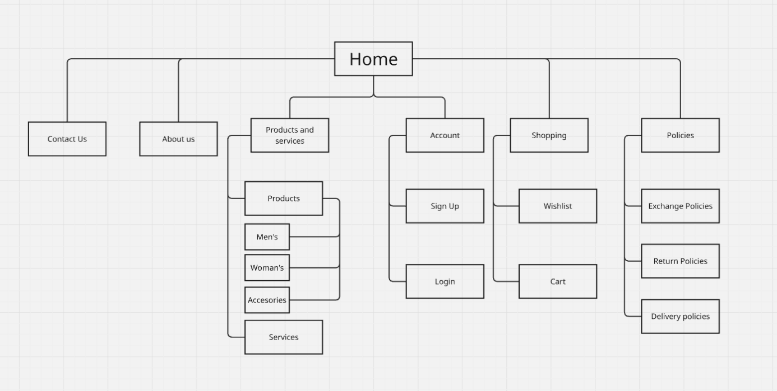

Task 3 – Role-play Scenario: Conduct a client meeting
Student note: Ensure that you have completed Part 1: Task 1 – Part 2: Task 3 before proceeding to this task.
Now that you have identified the requirements of the website, and completed initial website development planning, you will need to confirm your findings in Part 1: Task 1 – Part 2: Task 3 of this assessment with the client.
In order to do this, you will have a face-to-face meeting with the client regarding the website requirements and development plan.
The agenda items for this formal meeting are as follows:
- Confirm the website requirements that you have documented in Part 1 of this assessment.
- Discuss the structure of the website by sharing digital sitemap and digital wireframe.
- Ask open-ended questions for clarification (if needed).
- Confirm the user requirements and the structure of the website.
- Obtain client feedback and amend layout if required.
This role play will take approximately 10 to 15 minutes. To understand the assessment criteria for this role play, see the Assessment checklist.
Role of the student being assessed
During the role-play make sure that you use:
- clear, simple language and plain English.
- appropriate conventions, protocols and tone for your audience.
- listening and inclusive questioning techniques.
The Assessor may ask questions while the demonstration is taking place, or if appropriate directly after the activity has been completed.

Part 3: Creating the website
In this part of the assessment, you will be required to develop a website for TipTop Soles. You should refer to and incorporate your findings in Part 1 and Part 2 of this assessment when developing the website.

Task 1 – Develop a website
Using the text editor and the mark-up language identified in Part 2, create the structured and formatted website for the client.
Student Note: You must not use a program that generates code.
- Create and use an appropriate directory structure for the website.
- Build the page structure for your web pages using essential basic elements.
- Create the website homepage, about us page, and contact us page according to the requirements of the scenario.
- Each page must include:
  - A navigational menu of text links providing access to all pages requested by the client (links are only required to be functional for the three pages you created)
  - A footer with appropriate utility links and social media links
  - Company logo, which includes a link back to the home page
  - A current page indicator to clearly show a visitor where they are within the site.
- Use semantically correct structural mark-up to define sections of each page as needed.
- Style, format and lay out the pages using CSS:
  - Use one external CSS file for all styles i.e., no inline or internal styles.
  - Use consistent styles and layout across the site, including appropriate use of font stack, colours, line-spacing, etc.
  - Do not add unnecessary elements or attributes – use existing elements as selectors wherever possible.
  - Use ‘class’ and ‘id’ attributes appropriately.
  - Style hyperlinks appropriately for different states, such as visited and hover – do not use the default styles.
  - Style the current page indicator appropriately.
  - Use monochromatic colour theme.
Package your website code in a zip file, and submit a screen recording demonstrating the functionality of your website (with a visible electronic sticky note of your name displayed on screen). Submit the zip file and screen recording to your assessor as evidence of completion of this task.

Part 4: Test and validate the website
Now that you have completed creating the website, it’s time for you to test and validate it. Record your test results (including screenshots where indicated) in a word-processed document to provide to the client. Use specialised language where appropriate.

Task 1 – Test and validate the website
When completing this task please document all responses in the template provided in Appendix 2.
- Using the test approach and test cases that you created in Part 1, test your website and complete your testing checklist according to organisational procedures. Make sure that your testing includes the following:
  - Test your website in two common browsers; if you have difficulty accessing different browsers and versions, you can use an online testing site such as Browserling (Long URL: https://www.browserling.com/ )(include screenshots).
  - Validate your website (W3C Markup and W3C CSS validation) to ensure it meets web standards (include screenshots).
- Correct any cross browser testing issues and re-test your website to ensure these have been resolved. Discuss the difference in test results and what work was done to fix the issues (including screenshots of the different testing results).
- Explain the testing process and the results, including any outstanding issues and corrective actions.
- Check text equivalent for every non-text element and confirm text-only pages are logical and accessible.
- Check that the document can be read without style sheets.
- Confirm information and pages are not dependent on colour (operating in a monochrome environment).
- Verify pages operate on a text-to-speech browser using a screen reader.

Part 5: Obtaining feedback and sign-off
Once the desired product is ready and delivered to the client, it is important to obtain feedback and sign-off from the client.
Feedback can tell you how you have performed, if the requirements were met within the time and budget, and how satisfied the client is with your work.
In this section, you will be required to create a feedback document and a project sign-off document.

Task 1 – Prepare the feedback form
Use MS Word to create a feedback form to provide to TipTop Soles.

Task 2 – Prepare the sign off form
Use MS Word to create client sign off form to provide to TipTop Soles.

Assessment checklist
The following checklist will be used by your Teacher/Assessor to mark your performance against the assessment criteria of your project. Use this checklist to understand what skills and/or knowledge you need to demonstrate during this assessment event. All the criteria described in the Assessment checklist must be met.
Table 6 Assessment checklist
TASK/STEP # | Instructions | S | U/S | Assessor comments
Part 1  Task 1 | Assess if the student is able to demonstrate the following:  Details of user analysis are captured in the template. | ☐ | ☐
Part 1  Task 2 | Assess if the student is able to demonstrate the following:  Details of website requirements are captured in the template. | ☐ | ☐
Part 1  Task 3 | Assess if the student is able to demonstrate the testing approach, test case, testing checklist, and reasons for selecting the mark-up language. | ☐ | ☐
Part 2  Task 1 | Assess if the student is able to demonstrate the following:  Submit the digital wireframe screenshot(s) as evidence | ☐ | ☐
Part 2  Task 2 | Assess if the student is able to demonstrate the following:  Prepare an accessibility checklist as per the web standards, laws, and scenario provided. | ☐ | ☐ | Date and observation:
Part 2  Task 3 | Assess if the student is able to uses clear and detailed verbal language in order to convey explicit information clearly, showcase active listening and questioning skills and provided satisfactory answers to the questions asked. | ☐ | ☐
Part 3  Task 1 | Assess if the student is able to demonstrate the following:  Submit the code in a zip file and a screenrecording demonstrating the functionality of the website as evidence. | ☐ | ☐
Part 4  Task 1 | Assess if the student is able to demonstrate the following:  Test the website and complete the testing template (Appendix 2). | ☐ | ☐
Part 5  Task 1 | Assess if the student is able to demonstrate the following:  Prepare the feedback form. | ☐ | ☐
Part 5  Task 2 | Assess if the student is able to demonstrate the following:  Prepare the client sign off form. | ☐ | ☐

Appendix 1: Enterprise Accessibility Policy for Website Development
The following is an outline of Enterprise accessibility considerations with which must be complied with when developing a website either internally or for a client.
1. Images
Unless your photographs are solely decorative, ensure they have alternate (alt) text. The alt text for solely decorative pictures, such as a bullet point or border, should be blank or null. The long description attribute can only be used for alternative content that is particularly extensive or descriptive (longdesc). Unless the picture is part of a logo or brand name, the text should be utilised rather than an image.
Verify your alt text by hovering your mouse pointer over the image; a yellow box with a description of the image should emerge (unless it is for decoration).
This is because those who are blind or visually impaired listen to the alt text to determine what the image symbolises. When people, particularly those with vision impairments, raise the picture size of text given as an image, the text becomes illegible.
2. Audio and video recordings
Ascertain that video and audio content is accompanied by subtitles, captions, or, at the very least, textual transcripts. If a website has audio that plays automatically, ensure that users may pause or stop these sounds. Verify that your audio and video contain open captions (captions that are always available) or written transcripts and that your pages provide a pause or stop button for automatic audio.
Reason: persons who are hard of hearing rely on captions and subtitles to read what they hear. Automatically playing sounds without pausing or stopping them can be perplexing for consumers listening to the material.
3. Colours
Ensure that the colour of the text provided contrasts sharply with the colour of the background. Ascertain that colour is not utilised only to convey information (e.g., refrain from saying "choose the red circle to proceed"). Contrast your work by using dark backgrounds with bright writing or vice versa. To check your contrast, use the free programme (Colour Contrast Analyser) offered by Vision Australia.
Reason: Low contrast (e.g., light grey writing on a white backdrop) makes web pages difficult to view for everyone, but especially for persons with vision impairment. For persons with colour-related vision impairments, using colour to convey information is inappropriate.
4. Text
Verify that your text may be enlarged without impairing the page's or site's content or functionality. Avoid using text pictures just for ornamental purposes. Check that your text can be resized in Internet Explorer by selecting "view" and then "text size" and selecting "biggest."
Reason: Individuals with low vision must increase the text size on websites to read the material. The text should be text; graphics can become illegible when enlarged; therefore, use straight text and style appropriately unless it is a logo or brand name.
5. Links
Ensure that your links clearly state where they are going, what they are, and why they are there. If you include a link to a document, be sure to include the kind of document (DOC or PDF) and the file size.
Reason: Individuals listening to links must understand what the link is or signifies to decide whether to proceed to the destination or open the document. The file size informs users with sluggish connections how long the document will take to download.
6. Site navigation and structure
Ascertain that all areas of your website may be viewed without the use of a mouse. Ascertain that the order of reading and navigating is reasonable and intuitive. Ascertain that information can be accessed in a variety of ways.
Verify that the webpage can be accessed using the keyboard's "Tab," "Shift + Tab," and "Enter" buttons. Verify that the site makes sense and shows correctly by viewing pages in a text-only browser such as Lynx View, Charlotte Web Browser, w3m, browse or WebbIE. Look for a site search, a site map, relevant links, and basic navigation on your pages.
Reason: Individuals who use only their keyboard or speech will not access portions of the website that require a mouse click. Poorly created sites are difficult to navigate and make it tough for users to find what they're looking for. Individuals access websites in various ways, and providing several paths to your content results in a more intuitive and usable website.
7. Forms
Forms containing text entry fields, buttons, and checkboxes Assign labels immediately adjacent to fields you want visitors to enter or click on. Check that fields that require input (e.g., name, email, comments) have a label next to them that describes the data that should be entered.
Reason: Individuals who use assistive technology must recognise what goes into each field and will listen to the instruction or prompt to determine what goes into each field.

Appendix 2: Website test results documentation template
Use the following template to document your test results:
- Windows Operating System: You may use the Snipping Tool to record both screen and audio of the screen reader.
- Mac Operating System: You may use the Screenshot tool to record both screen and audio of the screen reader.
- Outline the testing approach that you used.
- Perform the initial testing and insert screenshots for each item listed in the following table.
Table 7: Website initial testing results
Item | Screenshots | Pass or fail
Initial browser test 1 |  | ☐ Pass  ☐ Fail
Initial browser test 2 |  | ☐ Pass  ☐ Fail
W3C Markup and W3C CSS validation test |  | ☐ Pass  ☐ Fail
Browser test 1 after corrections |  | ☐ Pass  ☐ Fail
Browser test 2 after corrections |  | ☐ Pass  ☐ Fail
- Discuss the difference between your initial test results and updated test results, as well as the work completed to fix the issues.
- Explain the re-testing process you undertook, including any outstanding issues and corrective actions which may be required.
- Perform the final testing and insert screenshots for each item listed in the following table.
Table 8: Website final testing results
Item | Screenshots | Pass or fail
Text equivalent for every non-text element and text-only pages are logical and accessible |  | ☐ Pass  ☐ Fail
The website can be read without style sheets |  | ☐ Pass  ☐ Fail
Information and pages are not dependent on colour (operating in a monochrome environment) |  | ☐ Pass  ☐ Fail
The website operates on a text-to-speech browser using a screen reader. | Either demonstrate this task to your assessor or submit a screen recording (including audio) of the output from a text-to-speech reader of any one webpage from the website. | ☐ Pass  ☐ Fail

Assessment feedback
NOTE: This section must have the Teacher/Assessor and student signature to complete the feedback. If you are submitting through the TAFE NSW online learning platform, your Teacher/Assessor will give you feedback via the platform.

Assessment outcome
☐ Satisfactory
☐ Unsatisfactory

Assessor feedback
☐ Has the assessment declaration for this assessment event been signed and dated by the student?
☐ Are you assured that the evidence presented for assessment is the student’s own work?
☐ Was reasonable adjustment in place for this assessment event?
If yes, ensure it is detailed on the assessment document.
Comments:

Assessor name, signature and date

Student acknowledgement of assessment outcome
Would you like to make any comments about this assessment?

Student name, signature and date

